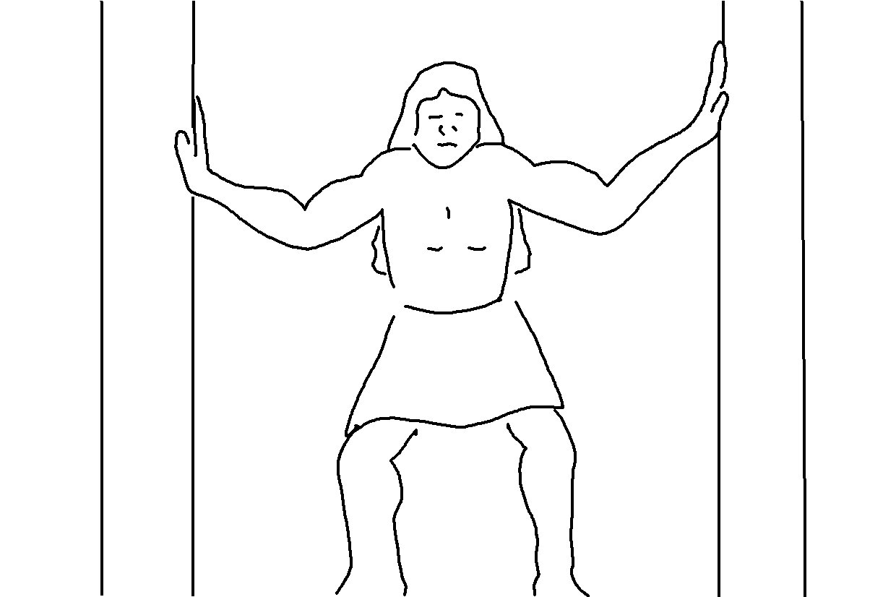
Choose today whom you will serve… But as for me and
my family, we will
serve the Lord.
Joshua 24:15_{NLT}

